# Introduction

This document was created to help you install, setup and use the Discord Plugin for Server Manager.

Plugin support was added to Server Manager and provided a way for plugins to listen for Server Manager alert messages.

This document assumes that Server Manager has been installed and setup and you have an understanding on how to use Server Manager.

**Note:** At the time of writing this document the current version of the Discord plugin is 1.0.5. As the Server Manager and the Discord plugin are developed this document may become outdated.

**Disclaimer:** No warranty is given to the user of this plugin for any problems that arise through the use of the Discord plugin, which may cause any problems, issues or corruption to Server Manager or the Game Server.

Contents

Introduction 1

Download the Plugin 3

Plugin Installation 3

Process 3

Plugin Configuration 5

New Process 5

Edit Process 8

Delete Process 9

Delete All Process 10

Update the Plugin 11

Process 11

Discord Webhook 13

Alert Types 14

# Download the Plugin

To use the Discord plugin, you must first download the latest version. The current download location of the plugin is [link](http://arkservermanager.azurewebsites.net/downloads/release/ArkServerManager.Plugin.Discord.zip). Once the file has been downloaded, you must extract the zip onto your desktop for use later.

# Plugin Installation

Installing the plugin is done using the Server Manager.

## Process

1. Start the Server Manager.
2. Click the Plugin button.

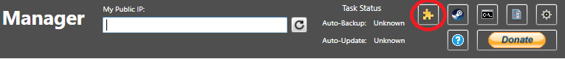

1. 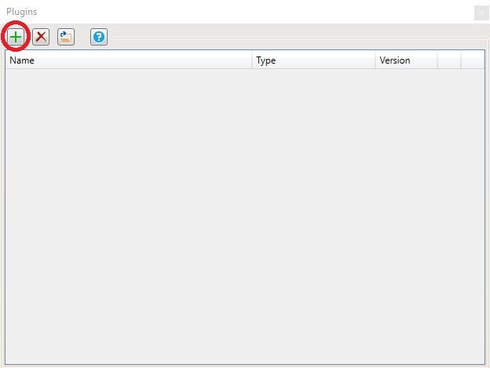After the plugin window opens, click the green ‘+’ button.
2. When prompted to select the plugin file, navigate to the desktop and select the extract file (ServerManager.Plugin.Discord.dll) and click the Open button.
3. 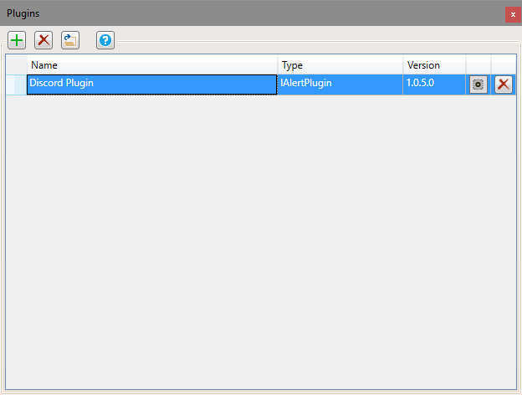If everything validated well, the plugin will now be displayed in the plugin window.

The plugin is now installed into the Server Manager.

# Plugin Configuration

Before the plugin can accept messages from the Server Manager, it must be configured.

## New Process

1. 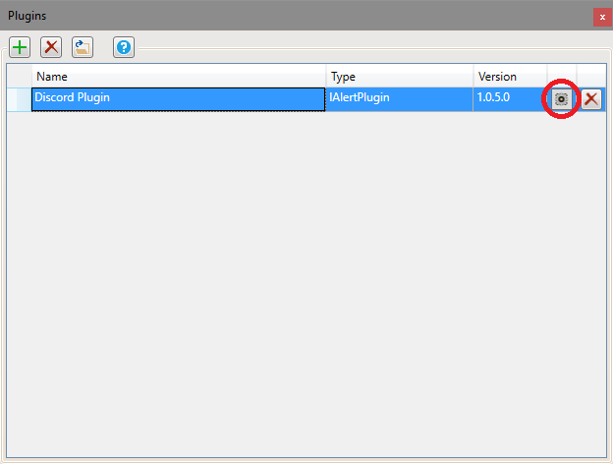Open the plugin configuration window, click the Cog button on the Discord plugin row.
2. Click the green ‘+’ button to create a new discord profile.

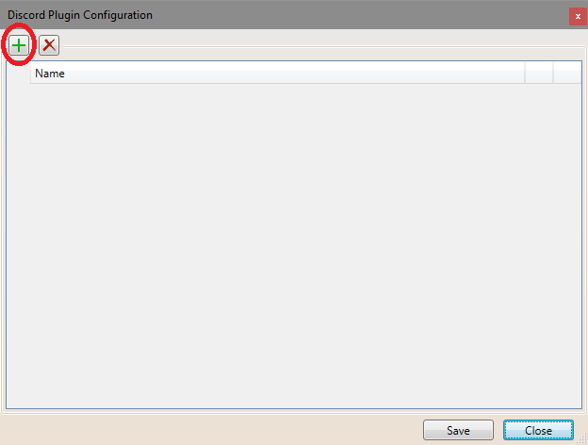

1. 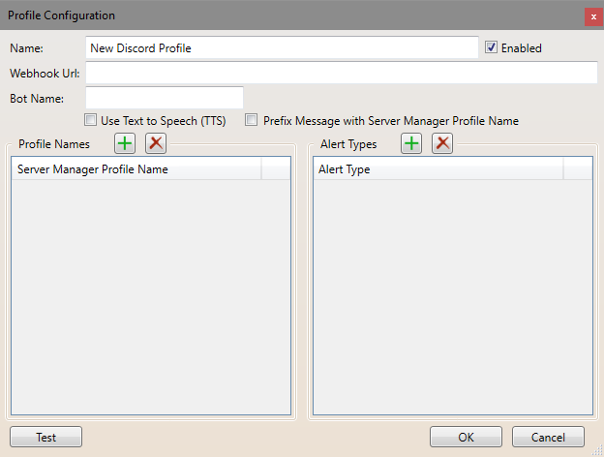A new profile window will be opened.
2. Change the values

**Name** – this is the display name for your discord profile, it is only used within the plugin so you can recognise which discord profile is which.

**Webhook Url** – this is the URL of the discord webhook you have configured in discord. For more information see the ‘Discord Webhook’ section.

**Bot Name** – this value is optional and will override the default bot name that was configured with your discord webhook.

**Use Text to Speech** – if enabled, the discord client will attempt to convert the message into speech; otherwise the message will only be sent as text.

**Prefix Message with Server Manager Profile Name** – if enabled, when the message is sent to discord, the message will be prefixed with the server manager Profile Name that sent the alert; otherwise only the message is sent.

**Enabled** – If enabled, set the profile as active and can be used when sending messages to discord; otherwise the profile will be excluded. This is a convenient way to disable profiles for short periods of time, without the need to delete them and add them later.

**Profile Names** – this list contains one or more Server Manager profile names. This is how the plugin system finds which Discord profile should receive the message. The names entered into this section MUST match the Server Manager profile names exactly.

**Alert Types** – this list contains one or more message alert types. Currently there are 7 different alert types (Error, Shutdown, ShutdownMessage, ShutdownReason, Startup, Backup, UpdateResults). Each message that is sent through the plugin system has an associated alert type and this is how the plugin system finds which discord profile should receive this message.

For more information on the different alert types, see the ‘Alert Types’ section.

1. After you have entered the values into the profile window, click the ‘Test’ button to make sure that you have everything setup correctly.
2. Once everything is ok, click the ‘OK’ button to save and close the window.
3. 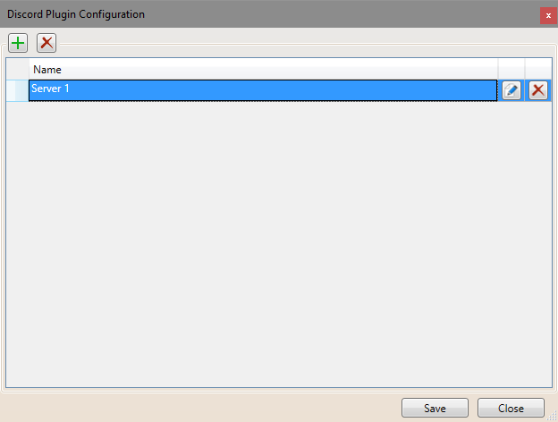You should now see the newly created profile in the Plugin Configuration window.
4. Click the ‘Save’ button.

## Edit Process

If the profile requires changes made to it, it can be edited.

1. 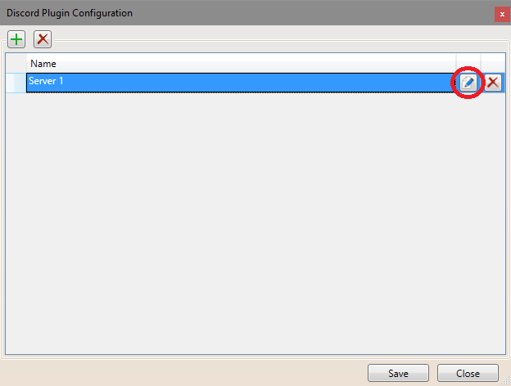Locate the profile to be edited, then click the edit button at the end of the row.
2. The profile window will be displayed, allowing you to change the profile values, modify the server manager profile names and modify the alert types.
3. After you have updated the values into the profile window, click the ‘Test’ button to make sure that you have everything setup correctly.
4. Once everything is ok, click the ‘OK’ button to save and close the window.

## Delete Process

If the discord profile is no longer required, it can be deleted.

1. 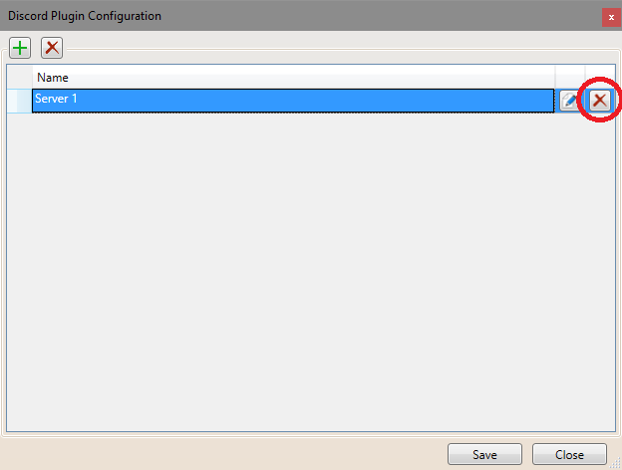Locate the profile to be deleted, then click the delete button at the end of the row.
2. Click the ‘Save’ button.

## Delete All Process

If none of the discord profile are required or you want to start fresh, you can delete all the profiles.

1. 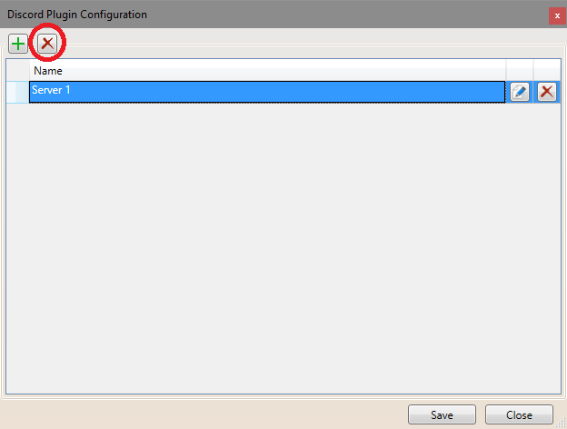 Click the ‘Delete All’ profile button.
2. Click the ‘Save’ button.

# Update the Plugin

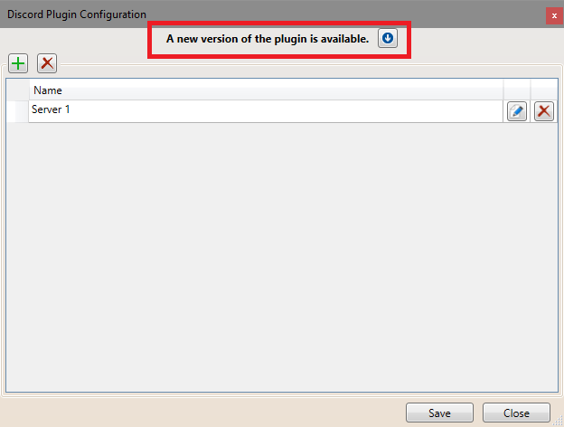When a new version of the plugin is available an update message will be shown in the configuration window. By using the download button, it will download the latest version to your desktop.

## Process

1. Once the new version has been downloaded, unzip the file onto your desktop.
2. Start the Server Manager.
3. Click the Plugin button.
4. After the plugin window opens, locate the Discord plugin then click the delete button at the end of the row.

Note: deleting the plugin **does not** delete the profile configurations.

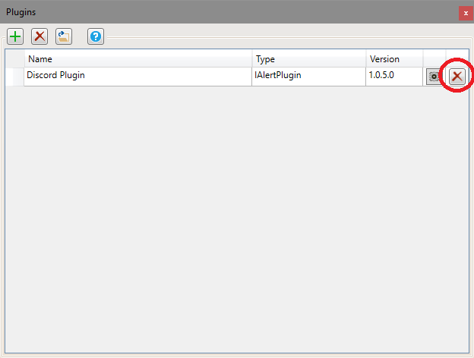

1. After the Discord plugin has been deleted, click the green ‘+’ button.
2. When prompted to select the plugin file, navigate to the desktop and select the extract file (ServerManager.Plugin.Discord.dll) and click the Open button.
3. If everything validated well, the plugin will now be displayed in the plugin window.

The plugin has now been updated.

# Discord Webhook

Discord's built in Webhooks function as an effortless way to get automated messages and data updates sent to a text channel in your server. By creating a Webhook endpoint in your server, you'll generate a Webhook URL that you can drop into many different services to link the two.

Here is a link on the discord website that explains the process of creating webhooks – [link](https://support.discordapp.com/hc/en-us/articles/228383668-Intro-to-Webhooks). If the link becomes unavailable, I would suggest using google to search for ‘Discord Webhook Creation’.

An example webhook url looks similar to this (not a real webhook url):

https://discordapp.com/api/webhooks/335378362400006096/gi4ogEKo9phnQMhtLUoJkSpH7cjMWTVXQNyqrwD8a7WbVtGNj69CXZw47AtJfOcY1xTq

# Alert Types

The current version of the Server Manager has seven (7) different message alert types. The alert type tells the plugins what type of message is being sent, and it can be used to determine the discord profile to use.

1. Shutdown – this alert type is used when the server is being shut down.
2. Startup – this alert type is used when the server is being started.
3. ShutdownReason – this alert type is used when the server is shutting down, and the reason message is sent.
4. ShutdownMessage – this alert type is used when the server is shutting down, and the shutdown messages are sent.
5. Backup – this alert type is used when the server is about the be saved and the warning is sent.
6. UpdateResults – this alert type is used when the auto-update has finished and sends a list of the changes that were applied (game server update and mod updates).
7. Error – this alert type is used when an error was encountered during any of the Server Manager auto processes. This alert can be used to notify server admins of potential problems with the game server.